6.5- Optimization Problems II- Exploring Solutions

Keep in Mind:
- The value of the objective function for a system of linear inequalities varies throughout the feasible region, but in a predictable way.
- The boundary intersection points are the vertices of the feasible region.
- These vertices represent the optimal solutions for the objective function
- If a vertex is not part of the solution set, then the optimal solution may be found nearby
- To verify an optimal solution, substitute its coordinates into each inequality in the system and evaluate.

Constraint:____________________________________________________________________

Feasible Region: _______________________________________________________________

Objective Function: _____________________________________________________________

Maximize/Minimize: ____________________________________________________________

Example. Restrictions: x, y ϵ R
Constraints: x + 3y ≤ 9, x – y ≤ 3, x ≥ -3
Objective function : P = 2x + y

- Draw a graph to model the situation
- What point in the feasible region would result in the maximum value of the objective functions?
- What point in the feasible region would result in the minimum value of the objective function?

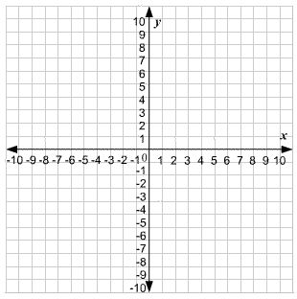

Example. Kathy and Ravi volunteer at the local food bank each weekend. Kathy can work no more than 10 hours per weekend. Ravi can work no more than 12 hours per weekend. The food bank can assign both of them for 18 hours or less per weekend. Kathy can fill 10 boxes with food in 1 hour, while Ravi can fill 12 boxes per hour. The food bank wants to maximize the number of boxes filled in one weekend by these two volunteers.

What are the variables? Represent them with a letter

Write out inequalities using these variables.

Graph and determine the equations.
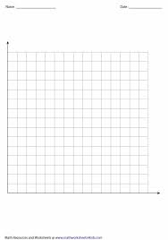

Example. A BC farmer wants to plant a combination of apple and pear trees that will maximize revenue.
She wants to plant no more than 500 trees altogether.
She wants to plant at least four times as many apple as pear trees
The yield per apple tree is 4 bushels, and the yield per pear tree is 3 bushels.
Apples pay the farmer $8.75 per bushel and pears pay 9.50 per bushel.

