6.6- Optimization Problems III: Linear Programming

Linear Programming: A mathematical technique used to determine which solutions in the feasible region result in the optimal solutions of the objective function.

To determine the optimal solution to an optimization problem using linear programming, follow these steps:
- Create an algebraic model that includes:
- A defining statement of the variables used in your model.
- Restrictions on the variables
- A system of linear inequalities that describe the constraints
- An objective function that shows how the variables are related to the quantity being optimized
- Graph the system of inequalities to determine the coordinates of the vertices of the feasible region
- Evaluate the objective function by substituting the values of the coordinates of each vertex
- Compare the results and choose the desired solution
- Verify your solution(s) satisfies the constraints of the problem situation

Example. L&G Construction is competing for a contract to build a fence.
- The fence will be no longer than 50 yd and will consist of narrow boards that are 6 in wide and wide boards that are 8 in wide.
- There must be no fewer than 100 wide boards and no more than 80 narrow boards.
- The narrow boards cost $3.56 each, and the wide boards cost $4.36.

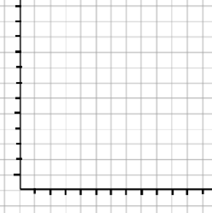
Example.

y ≤ 1, 2y ≥ -3x + 2, y ≥ 3x - 8

