6.2- Graphing Systems of Linear Inequalities
Goal: Explore graph of situations that can be modeled by system of two linear inequalities in two variables.
- The solution set of a system of linear inequalities in two variables x and y is the set of all points (x, y) that satisfy each inequality of the system.
- The graphical solution of such a system may be obtained by graphing the solution set for each inequality independently and then determining the region in common with each solution set.

For a system of linear inequalities, the solution is the region where the shading for each inequality overlaps.
STEPS:
- Change each inequality to y = mx + b form and graph (remember the rules for solid and dashed lines)
- Shade the appropriate area of each line. The solution lies in the double “cross hatch” area
- If the solution regions for the linear inequality in the system DO NOT overlap, there is NO solution.
- Be sure that you consider the range and domain restrictions if they exist
- Check your graph by selecting a coordinate point in the double “cross hatch” area.

Example 1.
- y ≥ –2x b) x + 3y ≥ 0
– 3 < x – y x + y ≥ 2
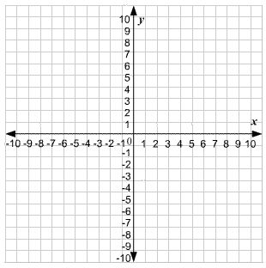

c) x + y ≤ -2
2y ≥ x

Example 2. Graph each system of linear inequalities. Justify your representation of the solution set.
a)

Example 3. Graph the solution set of the system of inequalities.

y ≥ 2x + 4

y ≤ –x – 2

x ≥ –6

