6.2- Graphing Systems of Linear Inequalities
Goal: Explore graph of situations that can be modeled by system of two linear inequalities in two variables.
- The solution set of a system of linear inequalities in two variables x and y is the set of all points (x, y) that satisfy each inequality of the system.
- The graphical solution of such a system may be obtained by graphing the solution set for each inequality independently and then determining the region in common with each solution set.

A system of inequalities is a combination of two or more inequalities. The solution of a system is the set of all ordered pairs that satisfy all the inequalities.

For a system of linear inequalities, the solution is the region where the shading for each inequality overlaps.
STEPS:
- Change each inequality to y = mx + b form and graph (remember the rules for solid and dashed lines)
- Shade the appropriate area of each line. The solution lies in the double “cross hatch” area
- If the solution regions for the linear inequality in the system DO NOT overlap, there is NO solution.
- Be sure that you consider the range and domain restrictions if they exist
- Check your graph by selecting a coordinate point in the double “cross hatch” area.

Example 1.
- y ≥ –2x b) x + 3y ≥ 0
– 3 < x – y x + y ≥ 2
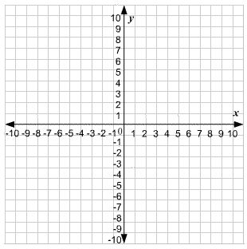

c) x + y ≤ -2
2y ≥ x

Example 2. Graph each system of linear inequalities. Justify your representation of the solution set.
a)

Example 3. Graph the solution set of the system of inequalities.

y ≥ 2x + 4

y ≤ –x – 2

x ≥ –6

- For a system of linear equations, the solution is the point where the two lines intersect.
- For a system of linear inequalities, the solution is the region where the shading of each inequality overlaps.

Example.
y ≤ -3x – 3
y ≥ -3x + 2

6.3- Graphing to Solve System of Linear Inequalities

Goal: Solve problems by modeling systems of linear inequalities. We have done a lot of graphing to solve systems. We will be building on this and showing possible solutions on the graph as well as written out.

Example.
a)
- y ≥ 2x – 1
- y < x + 5

b)
1. x ≤ 0
2. x ≥ -4
3. y ≥ 0
4. y ≤ 7

Example. For the system below, explain whether the boundaries and their points of intersection are a part of the solution region.

{(x, y) | x + y ≤ -2, x, y ϵ I}

{(x, y) | 2y ≤ x, x, y ϵ I}

Example. Consider the system of equations. 2x + y = 2, x – 3y = 15
Solve the system of equations graphically by:
- writing both equations in slope-intercept form
- making a table of values and plotting the points.

Example.
Graph the solution set for the following system of inequalities. State two possible solutions from the set. Check your work.

{(x, y) | 2x + y ˃ 6, x, y ϵ W}
{(x, y) | y ≤ 3, x, y ϵ W}

Example. To raise funds to buy new instruments, the band committee has 500 T-shirts to sell. The T- shirts come in red or blue. Based on sales of the same T-shirts at a fundraiser five years ago, the committee expects to sell at least twice as many blue T-shirts as red T-shirts.
- Define the variables and restrictions. Write a system of linear inequalities that models the situation.

- Graph the system of inequalities.

- Suggest a combination of T-shirt sales that could be made.

