6.4- Optimization Problems I: Creating the Model

GOAL: Create models to represent optimization problems

The objective is to find the maximum or minimum value of some quantity or how to achieve the max or min value. One method used to solve these problems is called linear programming.
- The objective function will be the quantity we want to maximize or minimize; it is dependent on other quantities.
- A constraint is a limiting condition on the quantities the objective function depends on. A linear inequality will model the constraints on the quantities.
- The constraints will produce a system of linear inequalities that will shape a feasible region on a coordinate plane. This region will contain all allowable combinations of quantities, one of which will optimize the objective function.

Example. A vending machine sells juice and water. The machine holds 100 bottles. At most 3 bottles of water are sold for each bottle of juice. Water sells for $1.00 and juice sells for $1.25. What combinations of bottles will bring in the most amount of money?
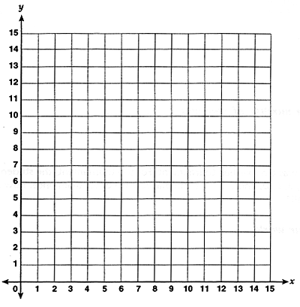

Example. A company makes custom scooters and bikes. The limited work area restricts the number of vehicles that can be built in one week; no more than 10 scooters can be built, no more than 15 bikes can be built, and no more than 20 vehicles of both kinds can be built. If the profit is $25 for a scooter and $50 for a bike, what should be the daily rate of production of both vehicles to maximize the profits?

- Identify the quantity to optimize.

- Define variables and state any restrictions.

- Write the system of linear inequalities to describe all the constraints of the problem and graph the feasible solution.

- Write an objective function.

Let’s check the feasible region for optimal solution:
- What happens to P as we move from left to right?
- What happens to P from bottom to top?

What points result in an optimal solution for:

Minimum value for P? Maximum value for P?

Example. Find the maximum and minimum values of the objective function given by
C = 7x + 3y subject to the following constraints:
x – y ≥ -4
2x + y ≤ 10
x ≥ 0
y ≥ 0

Therefore, the minimum value of C is _________ which occurs at _________ and the maximum value of C is _________, which occurs at _____________.

