AP English Literature and Composition
Summer Reading ELA 9A

Pre-Advanced Placement English Language Arts 9
Advanced Placement classes provide students the rigor and depth of instruction common to the college level classroom. Colleges and universities may award course credit to students earning acceptable scores on Grade Twelve AP exams that are administered each May. The benefits of enrollment in AP classes are many, including the development of strong study skills, an understanding of the college regimen and the potential of earning college credits while in high school. For parents, success on the Grade Twelve AP exams may translate into added savings on college tuition.
Success in Pre-AP and AP classes requires commitment and a “good faith effort” on the part of the student. Because AP courses are typically a student’s first exposure to the regimen of a college course, it is important that students recognize that Pre-AP and AP classes require active participation in the class. Note-taking, involvement in class discussions, a willingness to ask questions, having supplies and textbooks in class, prompt attention to make-up work or test corrections, and completion of all assignments are critical to a student’s success. Maintaining good attendance, prioritizing homework and study time, and a willingness to attend tutorials are expected of Pre-AP and AP students.
Parental support and encouragement provide a student with the foundation necessary to succeed in Pre- AP and AP classes. Students will find that Pre-AP and AP coursework typically requires more reading and homework, and preparation for AP exams requires effective time management and study skills. As students navigate their Pre-AP and AP courses, it is often a parent’s support that motivates the student.
Occasionally, a student, parent, or teacher realizes that enrollment in a Pre-AP or AP class is not in the student’s best interest. In such cases, with parent permission, students may withdraw from the class and return to the regular level course equivalent. A withdrawal form, including student, parent, and teacher signatures is required.
Introduction to Summer Reading
I am very excited about teaching next year's Pre-AP Literature & Composition class. The information below describes your summer reading and writing assignments. While I am busy this summer planning next year's work, I hope you will enjoy reading and completing the attached assignment. The summer reading program is an important feature of the AP English program as it allows us to cover a maximum number of titles and to begin the year with meaningful discussion. This important requirement will ease your transition into the AP Literature Program. Solid Advice: Don't let things go until the last minute.
Purpose Statement
The main purpose of the AP summer reading assessment is to extend the curriculum and allow advanced students an opportunity to explore a variety of literature. My philosophy is that summer reading should be both pleasurable and thought provoking, allowing the students to use this reading as a springboard into the material covered in AP Literature. Research continues to demonstrate that nothing will improve a student’s overall academic performance in school and in life better than reading. Therefore, Miller Comprehensive Catholic High School intends for all AP English students to experience this same wonderful opportunity for enlightenment through our summer reading program. While we hope that summer reading will provide a meaningful extension of a highly advanced college curriculum, our greatest hope is that it will stimulate continued appreciation for the joy of reading.
What is the result of summer reading?
When we begin our year together in September, we will have a solid foundation – something on which we can build throughout the year. The common language developed through the reading of The Book Thief will give you ALL a head start. The summer reading not only allows us to “start the year running” but also keeps our brains from getting mushy during your summer vacation. An active engaged brain is a fine result unto itself!
Grade Nine Summer Reading Information
Please acquire The Book Thief. You can find a copy at the Regina Public Library. They have 101 paperback copies and 15 audiobooks available. You can also borrow an ebook by visiting the RCSD Overdrive page using your school username and password (https://reginaca.libraryreserve.com/10/45/en/Default.htm) or the Regina Public Library Overdrive page (https://www.reginalibrary.ca/catalogue/ebooks) using your library card username and password. Please do not simply watch the movie. This will not help you with the literary content and it is NOT identical to the book.
Please complete the attached assignment for the novel.
It is due on the first day of school!
Note: If you need any help with the assignment, please visit one of the AP Nine Teacher’s sites. It will be updated for the fall semester and will contain some helpful material on the AP ELA A9 page. You may, however, also be required to research some of the material yourself. It’s a skill you’ll need soon. Good luck and enjoy!
Mr. Hambleton’s wiki can be found at: http://virtualham.wikispaces.com/
Ms. Thibeault’s Weebly is http://msthibeault.weebly.com/summerreading
Ms. Fairbairn’s Weebly is http://fairbs.weebly.com/
* Just because you’re using a teacher’s site does not mean you will be in his/her class!
ELA 9 Pre-AP Novel Study Suggested Summer Reading Package
Please read The Book Thief. You can find a copy in your local public library, online, etc.
Complete the activities below.
- Using the plot diagram below, summarize the main events of the novel.
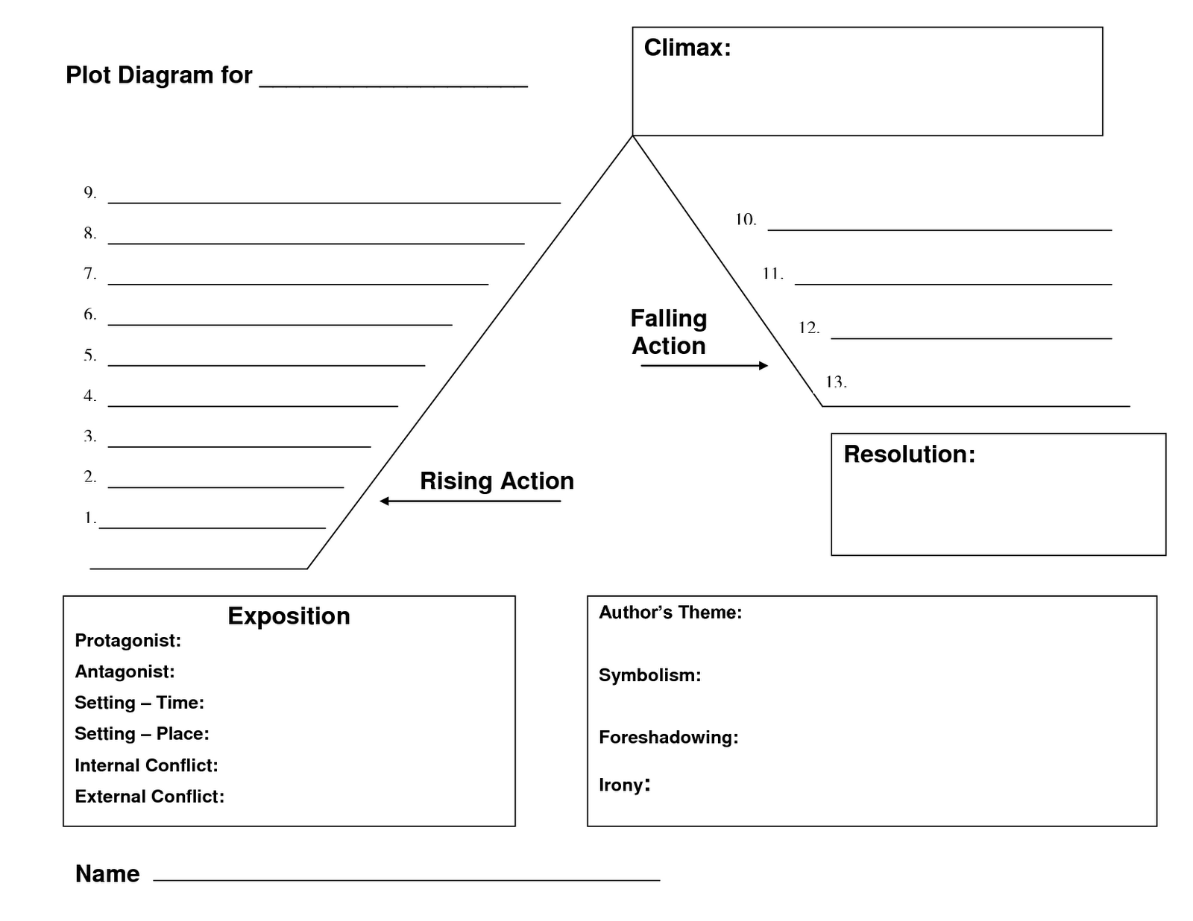
- Define the vocabulary below. Well-worded point form in your own words is expected.
- Conglomerate

- Prolific

- Innocuous

- Euphoric

- Flippant

- Deplorable

- Trepidation

- Accrued

- Ostracism

- Genially

- Microcosm

- Benign

- Provide two pieces of evidence from the novel supporting the following themes. Well-worded point form is acceptable.

  - Love

  - Literature and Writing

  - War

  - Mortality

  - Identity

  - Criminality

  - Language and Communication

  - Suffering

  - Courage

- Provide an example for the following connections. Use complete sentences.

  - Text-to-text:

  - Text-to-world:

  - Text-to-self:

