Greek Theatre
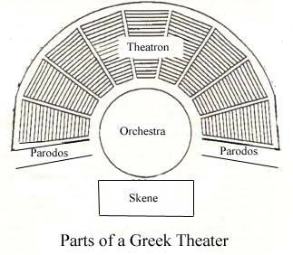
Greek tragedies and comedies were always performed in outdoor theaters. Early Greek theaters were probably little more than open areas in city centers or next to hillsides where the audience, standing or sitting, could watch and listen to the chorus singing about the exploits of a god or hero. From the late 6th century BC to the 4th and 3rd centuries BC there was a gradual evolution towards more elaborate theater structures, but the basic layout of the Greek theater remained the same. The major components of Greek theater are:
- Orchestra: The orchestra (literally, "dancing space") was normally circular. It was a level space where the chorus would dance, sing, and interact with the actors who were on the stage near the skene.
- Theatron: The theatron (literally, "viewing-place") is where the spectators sat. The theatron was usually part of hillside overlooking the orchestra, and often wrapped around a large portion of the orchestra (see the diagram above). Spectators in the fifth century BC probably sat on cushions or boards, but by the fourth century the theatron of many Greek theaters had marble seats.
- Skene: The skene (literally, "tent") was the building directly behind the stage. The skene was directly in back of the stage, and was usually decorated as a palace, temple, or other building, depending on the needs of the play. It had at least one set of doors, and actors could make entrances and exits through them. There was also access to the roof of the skene from behind, so that actors playing gods and other characters could appear on the roof, if needed.
- Parodos: The parodoi (literally, "passageways") are the paths by which the chorus and some actors (such as those representing messengers or people returning from abroad) made their entrances and exits. The audience also used them to enter and exit the theater before and after the performance.

