**Before We Start**

Do: Factoring Practice Worksheet/Review and Exploring Quad Functions Inquiry

*Terms*

* X-intercept
* Y-intercept
* Linear Factors
* Slope-intercept form
* Function

*Skills*

* How to evaluate a function f(x) by subbing in for x.
  + Evaluate $f\left(x\right)=2x^{2}-3x+4$ when x=3.
* Vertical Line Test
  + Glide a vertical line over the graph. If it crosses twice in any place, it is not a function.
* How to tell if a relation is a function
  + Cannot have repeat x-values
  + Must be one-to-one or one-to many
  + Cannot by many to one
* Solving a equation with one variable
* Graphing a linear relation
* Factoring
  + See practice sheet
* Factoring to solve an equation
  + Get everything on one side and 0 on the other side.
  + Factor.
  + Set each factor = 0. Solve.

**Chapter Seven: Quadratic Functions**

*Student Notes for Excellence and Cool Math Times*

* Quadratic Facts
  + A quadratic function will always have a degree of 2.
    - The first term will always have an exponent of 2. It will be the highest.
  + The graph of any quadratic function is a parabola (per-AH-blah). It has a single line of symmetry right down the centre.
    - Fun Parabola Fact: the “ends” reach out forever and ever and ever amen. They look like they are going to go straight, but they are technically still slightly curved and reaching outwards. I swear. Just trust me. It never ends. Ever.
  + Standard Form
    - $y=ax^{2}+bx+c$, where $a≠0$.
    - Characteristics of Standard Form
      * The highest or lowest point of the graph lies on the vertical line of symmetry.
      * If *a* is positive, the parabola “smiles.” (Opens UP)
      * If *a* is negative, the parabola “frowns.” (Opens DOWN)
      * Also, *a* determines the amount of openness of the parabola.
      * The value of *b* moves the parabola horizontally. This means the vertical line of symmetry also moves with it.
      * The value of *c* moves the parabola vertically. It is the y-intercept.

**7.1 Examples**

Use the following equation for all questions below: $y=(3x-2)(-2x+1)$

1. Rewrite the relation in standard form.
2. Is it a quadratic? (i.e. is it degree 2)
3. Does the parabola open up or down?
4. Write a quadratic equation that would open up.
5. Identify the y-intercept.
   * Vertex



* + - The minimum or maximum value of a parabola
    - If a is positive, you will have a minimum value at your vertex
    - If a is negative, you will have maximum value at your vertex.
  + Axis of Symmetry
    - Goes through the vertex
    - To find it, choose two points on the parabola have the same y-coordinate. Average the x-coordinates. That’s the line through x. This will also be the x-coordinate in your vertex.
      * To find the y-coordinate, sub that value into your equation and solve y.
  + Sketching Parabolas
    - Method 1: Make a table of values and sub into your equation. Plot those points.
  + Domain and Range
    - The domain will always be all the real numbers (unless it is word problem where we cut off part of the parabola, but that’s a different story).
      * Write it like this. $\{x|x∈R\}$
    - The range will be a subset of the real numbers.
      * It will be either $\{y|y≤\#, y∈R\}$ if your graph opens down
      * OR $\{y|y≥\#, y∈R\}$ if your graph opens up (because is greater to be happy).

**7.2 Examples**

Use the following equation for all of the questions below. $f\left(x\right)=-x^{2}+2x+8$

1. Find the y-intercept
2. Will this parabola have a max value or a min value?
3. Find the equation for the axis of symmetry.
4. Find the vertex.
5. Create a table of values.
6. Graph.

|  |  |  |  |  |  |  |  |  |  |  |  |  |  |  |  |  |  |  |  |
| --- | --- | --- | --- | --- | --- | --- | --- | --- | --- | --- | --- | --- | --- | --- | --- | --- | --- | --- | --- |
|  |  |  |  |  |  |  |  |  |  |  |  |  |  |  |  |  |  |  |  |
|  |  |  |  |  |  |  |  |  |  |  |  |  |  |  |  |  |  |  |  |
|  |  |  |  |  |  |  |  |  |  |  |  |  |  |  |  |  |  |  |  |
|  |  |  |  |  |  |  |  |  |  |  |  |  |  |  |  |  |  |  |  |
|  |  |  |  |  |  |  |  |  |  |  |  |  |  |  |  |  |  |  |  |
|  |  |  |  |  |  |  |  |  |  |  |  |  |  |  |  |  |  |  |  |
|  |  |  |  |  |  |  |  |  |  |  |  |  |  |  |  |  |  |  |  |
|  |  |  |  |  |  |  |  |  |  |  |  |  |  |  |  |  |  |  |  |
|  |  |  |  |  |  |  |  |  |  |  |  |  |  |  |  |  |  |  |  |
|  |  |  |  |  |  |  |  |  |  |  |  |  |  |  |  |  |  |  |  |
|  |  |  |  |  |  |  |  |  |  |  |  |  |  |  |  |  |  |  |  |
|  |  |  |  |  |  |  |  |  |  |  |  |  |  |  |  |  |  |  |  |
|  |  |  |  |  |  |  |  |  |  |  |  |  |  |  |  |  |  |  |  |
|  |  |  |  |  |  |  |  |  |  |  |  |  |  |  |  |  |  |  |  |
|  |  |  |  |  |  |  |  |  |  |  |  |  |  |  |  |  |  |  |  |
|  |  |  |  |  |  |  |  |  |  |  |  |  |  |  |  |  |  |  |  |
|  |  |  |  |  |  |  |  |  |  |  |  |  |  |  |  |  |  |  |  |
|  |  |  |  |  |  |  |  |  |  |  |  |  |  |  |  |  |  |  |  |
|  |  |  |  |  |  |  |  |  |  |  |  |  |  |  |  |  |  |  |  |
|  |  |  |  |  |  |  |  |  |  |  |  |  |  |  |  |  |  |  |  |

**Section 7.3 – Solving Quad Functions by Graphing**

* + Reminders
    - Quadratic means that the equation has x2 as the highest degree.
    - Standard Form: $y=ax^{2}+bx+c$, where $a≠0$.
      * When solving an equation, you want to get 0 on one side and everything else (in order) on the other side.
  + Zeros
    - The zeros are x-and y-intercepts.
    - The x-intercepts can tell us the start/end and of things on a parabola, for instance.
    - Y-Intercepts
      * Sub zero in for x and solve. Boom.
      * You will always have a y-intercept.
    - X-Intercepts (called the *Roots*)
      * Three Cases
        + 2 Intercepts

Sub zero in for y. Factor to solve. Set each bracket equal to zero. Boom.

You may want to use decomposition for this. Factor style is your choice though.

* + - * + 1 Intercept

The vertex lies on the x-axis. Still sub zero for y.

* + - * + No Intercepts

The parabola opens up and lies above the x-axis

The parabola opens down and lies below the x-axis

Check the min/max value and direction of parabola before you sub in to save yourself some work.

**7.3 Examples**

1. Name two examples of a quadratic equation
2. Name two non-examples of a quadratic equation.
3. Put $3x^{2}+2x-4=4x(3-x)$ into standard form.
4. 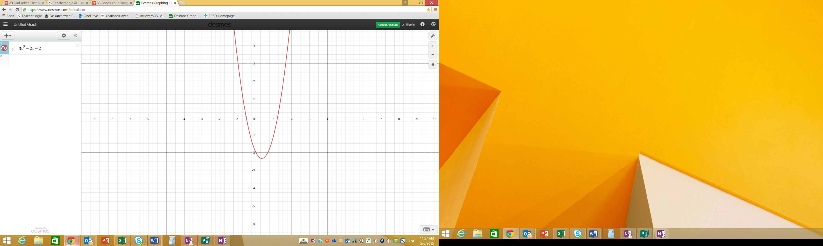Estimate the roots of the following graph. 🡪 🡪
5. Verify your solution with the equation $y=3x^{2}-2x-2$

**Section 7.4 – Factored Form of a Quadratic**

* + Factored Form
 $y=a\left(x-r\right)\left(x-s\right)$

   - * x = r and x = s are the zeros.
      * Linear equation for the axis of symmetry: $x=\frac{r+s}{2}$
      * Y-intercept, c, is $c=a∙r∙s$
        + Remember it because you can “see” it’s “butt”
    - This is good because you can graph it because you can see the zeros.
    - You can draw the parabola using the x-intercepts and another point on the parabola.
    - If there are no zeros for the function, you can’t write it in factored form.
    - If it only has one x-intercept, you can write the equation as $y=a(x-r)^{2}$

**Examples for 7.4**

1. 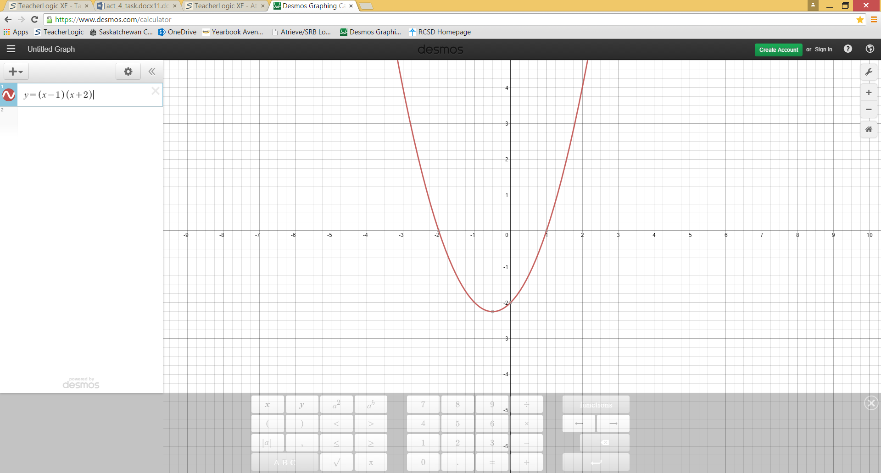Write an equation in factored form for the graph. (Hint: a=1)
2. Use the following equation for the next questions:
 $$f\left(x\right)=x^{2}-3x-5$$

  1. Write it in factored form.
   2. Determine the x-intercepts.
   3. Determine the axis of symmetry.
   4. Determine the y-intercept
   5. Sketch the parabola.

**Section 7.5 – Solving Quadratic Equations by Factoring**

* + Solving by Factoring (Not new, just Foundations 10 with a fancy title)
    - Start by writing the equation in standard form, and then factor.
    - Set each factor equal to zero and solve each.
    - Each solution is a solution to the original function.
    - There may be zero, one, or two solutions.

**Examples for 7.5**

1. 🡪 Factor using the AC Method
2. Solve the following by factoring: $4x^{2}+28x+49=0$.
   1. Solve for x.
   2. Verify your solution(s) by subbing in for x.
3. The roots of an equation are -5 and -7. What is one possible equation for these roots?

**Section 7.6 – Vertex Form**

* + Vertex Form
 $y=a(x-h)^{2}+k$

   - * Vertex: (h, k)
      * Axis of Symmetry: x = h
      * Parabola opens up when $a>0$. The minimum value of the function is k.
      * Parabola down up when $a<0$. The maximum value of the function is k.
      * Can tell you if there are one, two, or no zeros.
        + Two Zeros: the graph has a positive value or 0 for h and any value for k.
        + One Zero: the graph has no value for k and h is 0.
        + No Zeros: the graph has a negative value for h and any value for k.
    - Benefits: you sketch a graph more easily from this form.
    - Drawbacks: looks outlandishly hard. (But it isn’t, so this doesn’t actually count.)

**7.6 Examples**

1. Sketch the following function: $f\left(x\right)={2(x-3)}^{2}-4$.

|  |  |  |  |  |  |  |  |  |  |  |  |  |  |  |  |  |  |  |  |
| --- | --- | --- | --- | --- | --- | --- | --- | --- | --- | --- | --- | --- | --- | --- | --- | --- | --- | --- | --- |
|  |  |  |  |  |  |  |  |  |  |  |  |  |  |  |  |  |  |  |  |
|  |  |  |  |  |  |  |  |  |  |  |  |  |  |  |  |  |  |  |  |
|  |  |  |  |  |  |  |  |  |  |  |  |  |  |  |  |  |  |  |  |
|  |  |  |  |  |  |  |  |  |  |  |  |  |  |  |  |  |  |  |  |
|  |  |  |  |  |  |  |  |  |  |  |  |  |  |  |  |  |  |  |  |
|  |  |  |  |  |  |  |  |  |  |  |  |  |  |  |  |  |  |  |  |
|  |  |  |  |  |  |  |  |  |  |  |  |  |  |  |  |  |  |  |  |
|  |  |  |  |  |  |  |  |  |  |  |  |  |  |  |  |  |  |  |  |
|  |  |  |  |  |  |  |  |  |  |  |  |  |  |  |  |  |  |  |  |
|  |  |  |  |  |  |  |  |  |  |  |  |  |  |  |  |  |  |  |  |
|  |  |  |  |  |  |  |  |  |  |  |  |  |  |  |  |  |  |  |  |
|  |  |  |  |  |  |  |  |  |  |  |  |  |  |  |  |  |  |  |  |
|  |  |  |  |  |  |  |  |  |  |  |  |  |  |  |  |  |  |  |  |
|  |  |  |  |  |  |  |  |  |  |  |  |  |  |  |  |  |  |  |  |
|  |  |  |  |  |  |  |  |  |  |  |  |  |  |  |  |  |  |  |  |
|  |  |  |  |  |  |  |  |  |  |  |  |  |  |  |  |  |  |  |  |
|  |  |  |  |  |  |  |  |  |  |  |  |  |  |  |  |  |  |  |  |
|  |  |  |  |  |  |  |  |  |  |  |  |  |  |  |  |  |  |  |  |
|  |  |  |  |  |  |  |  |  |  |  |  |  |  |  |  |  |  |  |  |
|  |  |  |  |  |  |  |  |  |  |  |  |  |  |  |  |  |  |  |  |

1. State the domain and range of the above function.
2. A soccer ball is kicked from the ground. After 2 seconds, the ball reaches its maximum height of 20 m. It lands on the ground after 4 seconds.
   1. Determine the quadratic function that models the height of the kick.
   2. Determine any restrictions on the domain and range for this problem.
   3. What was the height of the ball at 1 second?
   4. When is the ball at the same height on the way down?

**Section 7.7 – Solving Quadratic Equations Using the Quadratic Formula**

* + Solving Using the Quadratic Formula
    - You can use the quadratic formula to solve any equation.
 $x=\frac{-b±\sqrt{b^{2}-4ac}}{2a}$

   - To do this, set your equation equal to zero, then sub into the equation.
    - Inadmissible solution
      * A root of a quadratic equation that doesn’t actually lead to a solution that works in the original equation.
      * Always sub into your original equation to find this buggers.
    - If $b^{2}-4ac$ is negative, you won’t actually get an answer.
    - If $b^{2}-4ac$ is a perfect square, you can factor it to get your answer.

**7.7 Examples**

1. Solve the following equation: $6x^{2}-3=7x$.
2. A store rents an average of 750 video games each month for $4.50 each. The owners of the store want to raise the rates to increase the revenue to $7000 per month. However, for every $1 they increase, they know they rent 30 less games per month. The following relates the price, p, and revenue, r. $$\left(4.5+p\right)\left(750-30p\right)=r$$ 
   Can the owners increase the rental rate enough to generate revenue of $7000?

**REVIEW TASK**

* Create a chart as to when you should use each of the forms of the equation for a problem. Include the name of the form, the written expression of the form, what info you might get, as well as what info you will be seeking out. Create a sample problem for each.