The Times in Which Shakespeare Lived

There are five major advancements in human civilization that happened starting in the 13th century and ending near the 17th century. They are The Magna Carta, the Black Death, The Renaissance, The Printing Press, and the Reformation.

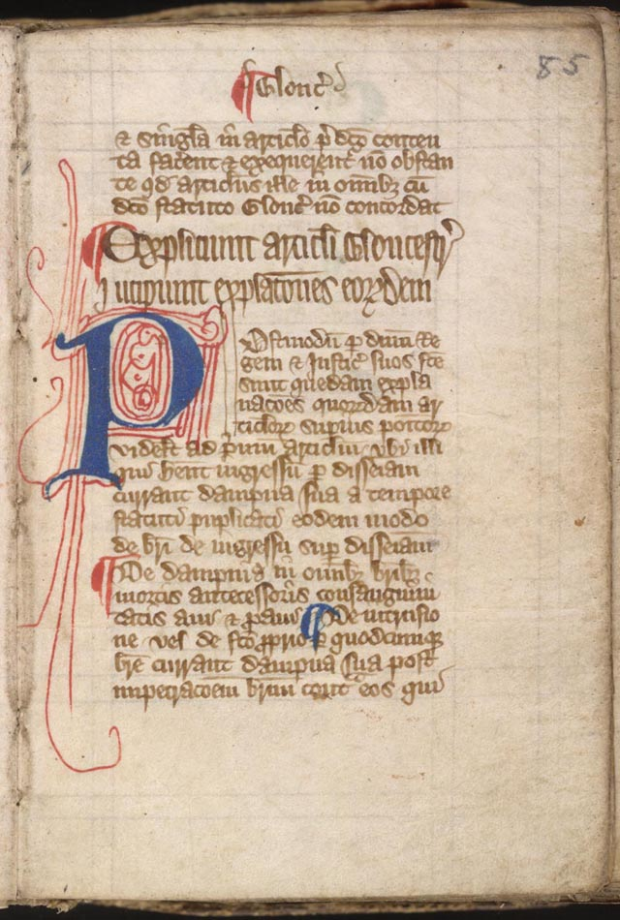
Magna Carta

The Magna Carta was a document that limited the power of kings in Britain. The document, essentially a peace treaty between John and his barons, guaranteed that the king would respect feudal rights and privileges, uphold the freedom of the church, and maintain the nation’s laws.

King John became king of England in 1199, following the death of his brother, King Richard the Lion- heart. He was not the greatest king, and he lost the duchy of Normandy to the French king and taxed the English nobility heavily to pay for his foreign travels and loss. After John failed to regain Normandy in 1214, Stephen Langton, the archbishop of Canterbury, called upon the barons to meet and demand a charter of liberties from the king. In 1215 the barons rebelled against John, and he had no choice, but to give in to their demands.

At first, the Magna Carta was a failure in that civil war broke out and John ignored his obligations under the charter. Upon his death in 1216, his son, King Henry III, reissued it. It was reassured a third and final time in 1225 where it formally entered English Statute Law.

The Black Death

Remember social studies

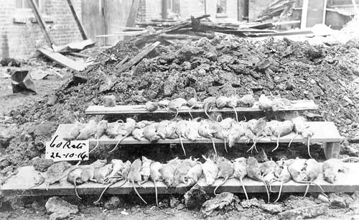

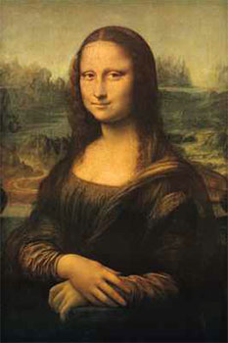
The Renaissance

The word “Rinascenza,” Italian for “rebirth”, from which Renaissance derives was coined by the Italian historian Giorgio Vasari in 1550 to refer to what Vasari saw as having taken place in Italy, and later spread to the rest of Europe, over the previous two centuries: a rebirth of ideas and of the aesthetic values associated with the classical cultures of ancient Greece and Rome. This cultural movement spanned from approximately the 13th to the 17th century.

Humanism- emphasize the value of human beings

Renaissance Humanism-rediscovery of Greek and Roman thought and literature

It was a time of growing knowledge, the idea of humanism, and freethinking. People that are associated with this time are: Michelangelo, Leonardo Da Vinci, Isaac Newton, Galileo Galilei, Ben Jonson, Christopher Marlowe, William Shakespeare, Thomas More, John Cabot, Jacques Cartier, Samuel de Champlain, Christopher Columbus and many, many more.

The Printing Press

Johannes Gutenberg (c.1398-1468), the son of a noble family of Mainz, Germany devised an alloy of lead, tin and antinomy that would melt at low temperature, cast well in the die, and be durable in the press. By 1452, with the aid of borrowed money, Gutenberg began his famous Bible project. Two hundred copies of the two-volume Gutenberg Bible were printed, a small number of which were printed on vellum. Printing could and did spread new ideas quickly and with greater impact.

The Reformation
The Protestant Reformation was a major 16th century European movement aimed initially at reforming the beliefs and practices of the Roman Catholic Church. In 1517, Martin Luther wrote 95 theses which were against the church and posted them on a castle in Wittenburg. Protestant churches developed during this time.

Elizabethan Renaissance

The manifestation of English Renaissance culture in the early 16th century was followed near the end of the century by an extraordinary cultural flowering of a different character- the Elizabethan Renaissance.
During this Era...
Shakespeare lived during the Elizabethan Era (1558-1603). During this time, Queen Elizabeth I was the Ruler of England. Queen Elizabeth I was the daughter of Henry VIII, famous for all his wives, and the sister of Queen Mary, who received her nickname Bloody Mary for all the public executions she ordered against the Protestants.
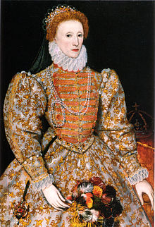
Before Queen Elizabeth became ruler, England was in poor conditions. It was almost bankrupt, and there were many religious disputes between the Catholics and the Protestants. Elizabeth, however, proved to be a strong leader. She was clever, well-educated, loved music, dancing and theatre and her people adored her.
The Spanish Armada was defeated making England the new, most powerful country in the world at the time.
The Age of Exploration was on and Sir Francis Drake had circled the globe.

London During the Elizabethan Era
London is where most of Shakespeare’s plays were held, where the Queen usually held her court, and where over 200 000 people called home. However, Shakespeare’s London was also dirty and overcrowded. Disease was rampant and public sanitation was practically nonexistent. Such conditions made rats inevitable and the rats carried a disease and passed on the Black Plague.
Crimes and violence were common in London and in every part of England. The laws were extremely harsh. Murders and other serious crime were punished by public execution. Traitors were dragged into public to be hanged and then drawn and quartered. Their bodies were cut before death, disembowelled, the entrails burned in a fire, the trunk cut into four parts then dipped into tar to be displayed in various parts of the city. The head was often impaled on the London Bridge. Noblemen were beheaded by axe. Being burned at the stake was the penalty for witchcraft, religious heresy, and women who poisoned their husbands.
People that lived in London
Although conditions in London were somewhat harsh, they were improving and as a result, most of the citizens in London had a festive outlook. They enjoyed dancing, singing, music and drama and often had many festivals.
They were also bloodthirsty. They liked to watch cock fighting, where two roosters fight to the death, and animal baiting. This is where a large animal was tied to a stake, and then a pack of dogs was let loose to attack it. The fight would last a good portion of the day and resulted in several dogs dead or disabled. They also flocked to public executions.
Elizabethan Theatres
Originally, drama in England took place anywhere, such as inns, barns etc. However, as drama and plays became more popular in England, more room was needed and theatres were built.
The Globe Theatre, the theatre Shakespeare produced his plays in was built in 1599

The stage was built on three levels:
- A platform with a trap door for the main action
- A second level for windows and balconies as part of the scenery
- A third level representing Heaven
They did not have elaborate scenery or special lighting effects, but they did have elaborate costumes.
All roles were played by men. Young boys with high voices and no facial hair played the roles of women and girls.
Elizabethan Audiences
Shakespeare’s plays drew in all types of people from the rick aristocracy of London to the working class men to the unemployed to Queen Elizabeth.
The working men and the poor, known as the “groundlings” generally sat in the pit, or the floor, in the theatre. They were known to be a rowdy group that would feel no shame in throwing vegetables and garbage at the stage and actors if the play did not hold their interest. The pit could hold up to 600 people all jammed in together.
The citizens with money (students, merchants and nobility, were seated on benches and balconies.
Elizabethan audiences were temperamental and demanding of the playwright. They wanted a rapid pace of action. They were superstitious, and as such, often demanded this type of action on the stage. However, at the same time they also enjoyed Shakespearean comedies as they provided an escape from their own lives, similar to the reason we watch reality TV, sitcoms, and movies.
